Air Purifier & Humidifier using Water as a Filter

Air pollution has crossed all bounds in 2021. WHO estimates that around 7 million people die every year from exposure to polluted air. The spread of air pollution is so high that about 91% of the world population is exposed to air pollution.
Well this also means that the air you breathe in your house is polluted. To counter this issue we here develop a mini air purifier with that does not use expensive filters but rather uses water as an air filter. Also it acts as an air humidifier and can be used as oil diffuser too which helps you relax and also kills certain bacteria and viruses present in the air.
The mini Air Purifier brings up the following key aspects
- A Low Cost Purifier
- No Expensive Filters Just Water
- Quiet Operation
- Easy Maintenance
- Also acts as a Humidifier
- Low Power Consumption
- Easy To Use
- Can be used as an Oil Diffuser
The system makes use of 2 x high power low noise centrifugal fans that are used to suck in air through a protection mesh. The pulled air is then passed through a water tank situated at the bottom of the purifier. The air passed through water gets auto purified as water traps dust, fungi, bacteria etc in the water. The resulting air rising through the water is a high humidity cool air.
Also added essential oils to the system allow for humidifying the area/room with essential oils which are researched to kill certain types of bacteria fungi in air and help humans relax. Also some essential oils are researched to provide various health benefits when inhaled.
Components:
- Air Blower Pumps
- Water Tank
- Pipe
- Pipe Fittings
- Nozzle
- Pipe Connector
- Transformer/Adapter
- Protective Mesh
- Monitoring Glass
- Mounts and Joints
- Base Frame
- Supporting Frame
- Screws and Fittings

Advantages:
- A Low Cost Purifier
- No Expensive Filters Just Water
- Quiet Operation
- Easy Maintenance
- Also acts as a Humidifier
- Low Power Consumption
- Easy To Use
- Can be used as an Oil Diffuser

Disadvantages:
- It doesn’t kill combat mold and fungi.
- Doesn’t remove odors as well as an active carbon filtration system.

Block Diagram

Front View
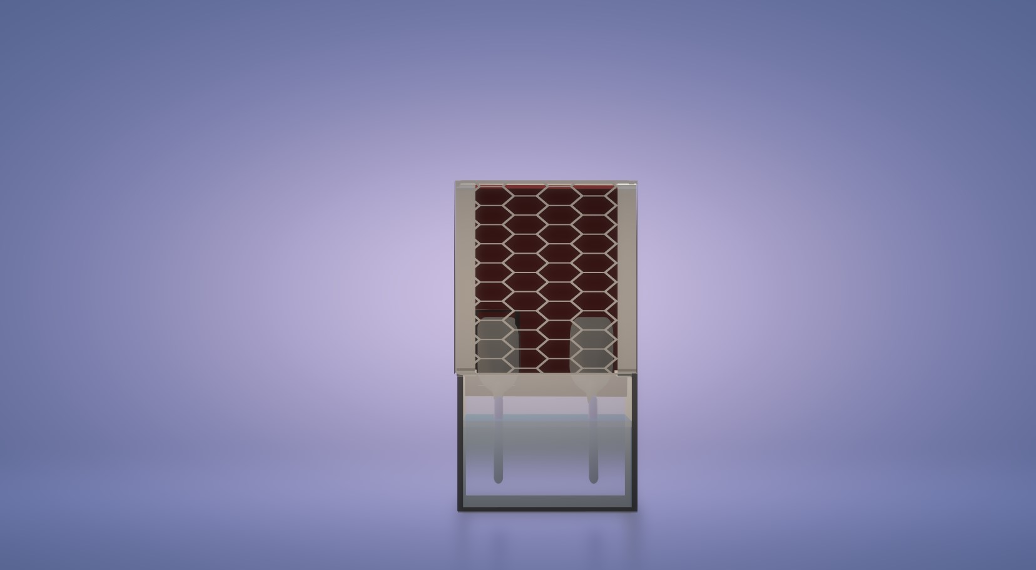

Side View
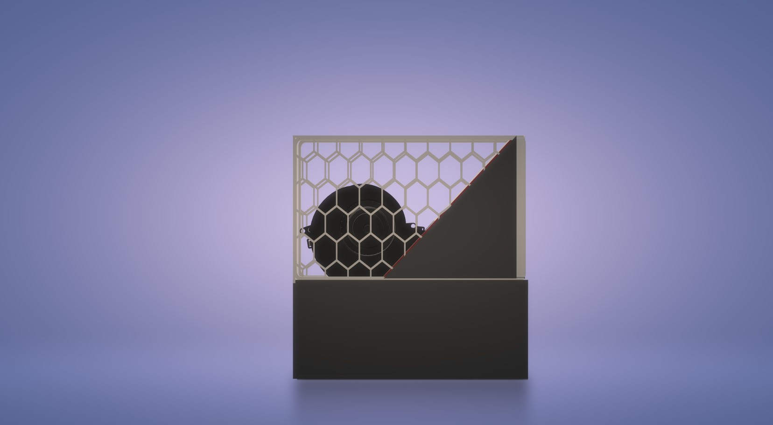
3D View
